X0060

Personal and Career Objective

Kalai, Kalimani Velaitham

014-6260589

Klai202p@gmail.com

117, Jalan Desa Ampang, Taman Desa Ampang

My Principle of Life is to keep everything Simple yet Significant regardless it is Happiness, Career, Work, Success, Learning or Managing self or others.

**Career Objective:** Driven by a passion for guiding and empowering young individuals, I aspire to become a **Subject Matter Expert** dedicated to **inspiring, mentoring, and coaching**. My goal is to profoundly impact the lives of the next generation, equipping them with the **skills and mindset** needed for resounding success in any path they pursue, while also contributing to the growth and excellence of your esteemed company."

Active Volunteer

Social Support

|  |  |  |  |
| --- | --- | --- | --- |
| Company | Industries | Area | Position |
| Peoplelogy,  Kuala Lumpur | Service  Industries | Learning and Development | Head of Training |
| AIA Bhd,  Kuala Lumpur | Financial Institution | Learning and Development | Head Of Training |
| Redberry CC,  Kuala Lumpur | Business Process Outsourcing | Operation Management | Operations Director |
| Astro Malaysia,  Selangor | Malaysia Satellite TV and Broadcast | Operation  Management | Head Of Department |
| UTS Marketing,  Kuala Lumpur | Business Process Outsourcing | Project Management | Account Director |
| AIA Bhd,  Kuala Lumpur | Financial Institution | Bancassurance | Outsource Manager |

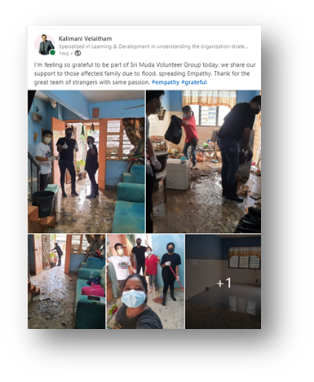

About

Experienced business leader with a Master's in Business Administration and 16 years of proven success across diverse industries, including Contact Center, BPO, Insurance, Financial institutions, Digital, TV, Radio, and Commerce. Adept in Training & Development, Human Resource and Outsourcing Management, Quality Assurance, Compliance Management, Customer Portfolio Management & Revenue Enhancement, and Contact Center Operations.

Notably, I've fortified my expertise in Learning and Development, augmenting my skills in Employee Engagement Strategy, Talent Discovery, Development, and Deployment. I've delivered exceptional consultation services

Professional Skills: **Framework, Training Design and Delivery, Needs Assessment, Adult Learning Principles, Presentation Skills, Active Listening, Conflict Resolution, Learning Management Systems (LMS),Evaluation and Feedback**

Experiences

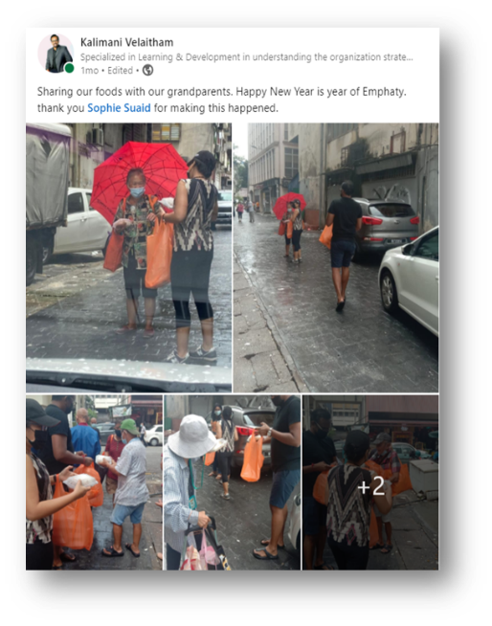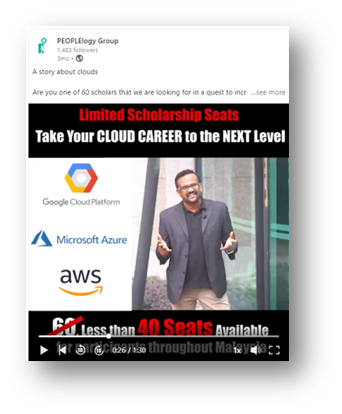

Adaptive Transformation: Transformed content creation challenges into successful behaviour-changing training by utilizing diverse theories and tools.

Strategic Achievement: Directed lasting leadership programs within tight budgets and deadlines, consistently meeting objectives.

Triumph over Setbacks: Turned initial obstacles into cross-border success, launching the Direct-to-Customer Omnichannel Learning Academy in Malaysia (June 2019) and later in AIA Singapore (Sept 2020).

Empowered Team: Overcame coordination challenges, empowering 7 trainers to achieve successful outcomes through strategic mentorship.

Adaptive Success: Excelled as a Training Provider, navigating challenges to deliver effective results-focused training.

Strategic Program Leadership: Orchestrated a triumphant 2019 program for corporations using the ADDIE Model, resulting in the impactful Kick-Patrick Module.

Certification Impact: In 2020, led Certification Programs for EPSON, GHL, Rapid Bus, Macdonald, Asia Aquaculture, and Synergy Sterilisation. Certified 200 individuals, shaping future leaders.

Dynamic Team Management: Directed 5 trainers and freelancers, fostering a high-performing team for impactful training.

Resilience and Success Stories

Host and Moderator for

Talk Show & Live Webinar



Adaptive Budget Mastery: Orchestrated the effective management of annual marketing budgets, continually refining strategies for enhanced project ROI and response rates.

Strategic Tool Maximization: Leveraged cutting-edge tools, capitalizing on data mining and precise targeting to elevate project performance.

Channel Synergy: Forged robust partnerships with channel collaborators, amplifying package effectiveness through seamless collaboration.

Cost-Savings and Revenue Surge: In 2015, engineered a triumphant financial transformation, reducing costs by 1.5 million while propelling revenue for the revenue enhancement team by 20%.

Education Background

|  |  |  |  |
| --- | --- | --- | --- |
| Education | Majoring | Completion | Institute |
| Master | Business Administration | 2010-2012 | West Coast University |
| Executive Diploma | Business Leadership | 2008-2010 | UTM |
| Diploma | Electrical Engineering | 2001-2003 | INTI University |
| SPM | Science Stream | 2000 | PD High School |

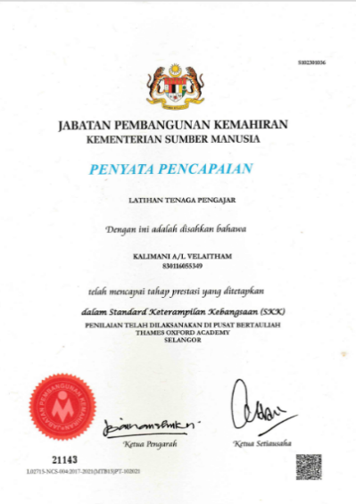

Reference & Testimonials

|  |  |  |  |
| --- | --- | --- | --- |
| Company | Contact Number | Name | Position |
| AIA | References available upon  request | Tee Soon Kiat | Head OF TM |
| UTS | Caryn | HR Director |
| ASTRO | Steven | Sales Director |
| REDBERRY | Zack | Business Director |

